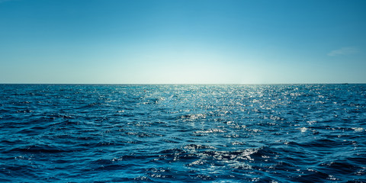

Dear Lord, today I thought of the words of Vincent van Gogh: “It is true there is an ebb and flow, but the sea remains the sea.” You are the sea. Although I experience many ups and downs in my emotions and often feel great shifts and changes in my inner life, you remain the same. Your sameness is not the sameness of a rock, but the sameness of a faithful lover. Out of your love I came to life; by your love I am sustained; and to your love I am always called back. There are days of sadness and days of joy; there are feelings of guilt and feelings of gratitude; there are moments of failure and moments of success; but all of them are embraced by your unwavering love.
My only real temptation is to doubt in your love, to think of myself as beyond the reach of your love, to remove myself from the healing radiance of your love. To do these things is to move into the darkness of despair.
O Lord, sea of love and goodness, let me not fear too much the storms and winds of my daily life, and let me know that there is ebb and flow but that the sea remains the sea. Amen.

Henry Nouwen

